**FIRE ALARM SYSTEM**

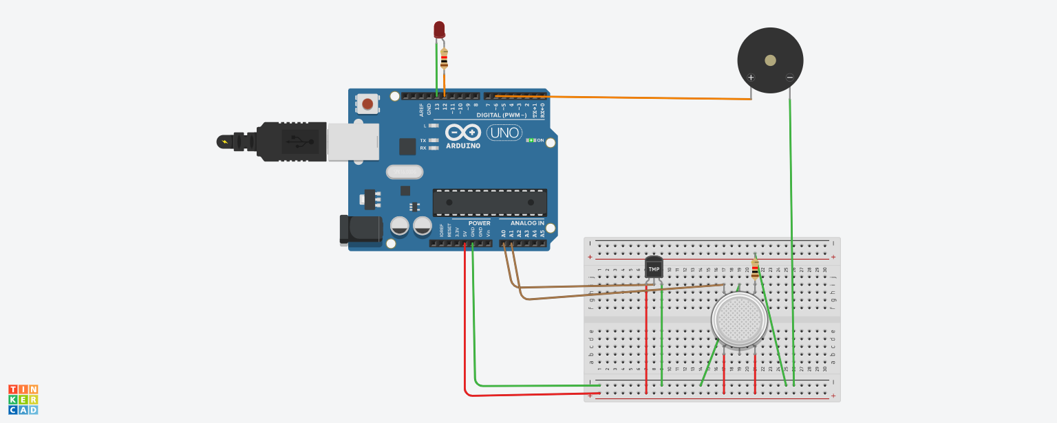

**CODE:**

float temp;

float vout;

float vout1;

int LED = 13;

int gassensor;

int piezo = 7;

void setup()

{

pinMode(A0,INPUT);

pinMode(A1,INPUT);

pinMode(LED,OUTPUT);

pinMode(piezo,OUTPUT);

Serial.begin(9600);

}

void loop()

{

vout=analogRead(A7);

vout1=(vout/1023)-5000;

temp=(vout1-500)/10;

gassensor=analogRead(A0);

if (temp>=80)

{

digitalWrite(LED,HIGH);

}

else

{

digitalWrite(piezo,LOW);

}

if (gassensor>=100)

{

digitalWrite(piezo,HIGH);

}

else

{

digitalWrite(piezo,LOW);

}

Serial.print("in DegreeC= ");

Serial.print(" ");

Serial.print(temp);

Serial.print("\t");

Serial.print("GasSensor= ");

Serial.print(" ");

Serial.print(gassensor);

Serial.println();

delay(1000);

}